Dana M Small
© Ms Category Management
A

Whitepaper: Managing Creative Advertising Agencies Through a Product’s Life Cycle

Table of Contents

BackGround 3

Introduction 4

The product lifecycle 5

Why Product lifecycle matters 7

Product Lifecycle Characteristics
Market Strategy Changes
Agency Work (Support)
Tactic/Project Level Changes

Brand’s risk tolerance vs. agency reliance 12

Best Practices in agency management 13

Key Takeaways 16

BackGround

The advertising industry Worldwide Media spending forecast is roughly up 5.1% for 2020, at $628B. (Ad Age – Marketing Fact Pack 2020). The industry is roughly split between media buying and planning (65-90%) and creative advertising (10- 35%). This white paper is focused specifically on the 35% of creative advertising.

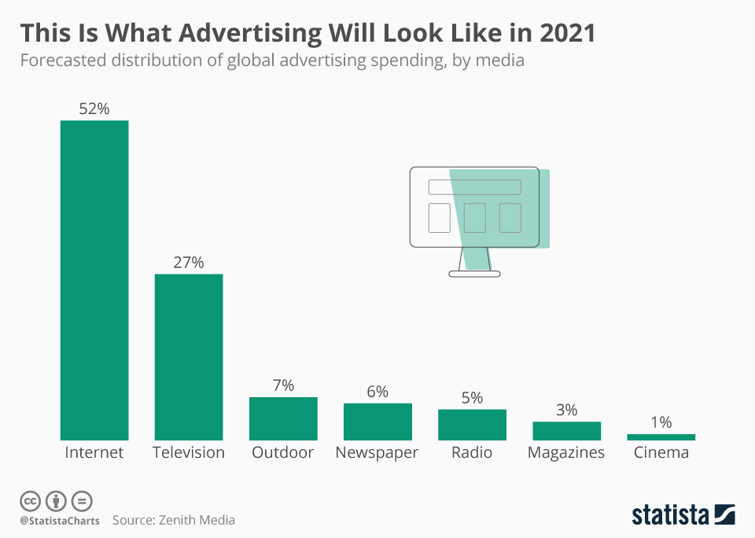
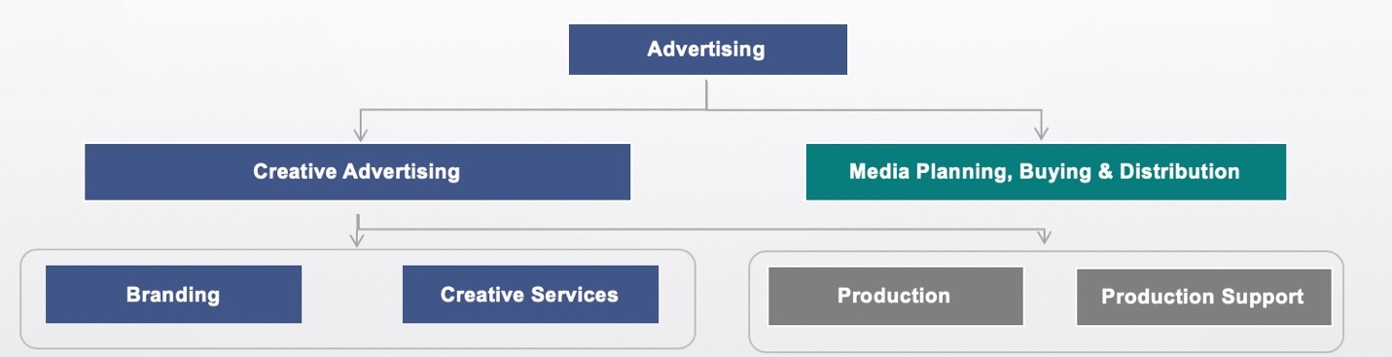

Introduction

Managing creative advertising agencies has changed over the years when it comes to strategic sourcing.
This was written with a BioPharma focus, buy in speaking with others in retail, financial services, CPG and other industries, it appears the theory holds true.
(With the clear exception when the buyer becomes a large enough portion of the overall industry spend, they are able to write their own rules, pricing and terms.)
There are four alternative factors outside the norm that should be considered, when managing an agency dependent upon product lifecycle:

- Product’s Placement in the product lifecycle
- Level of work being created (strategic vs. tactical) due to Marketing Mix
- Budget size to support advertising work
- (Non-mandated sourcing) Marketing’s willingness to work with sourcing.

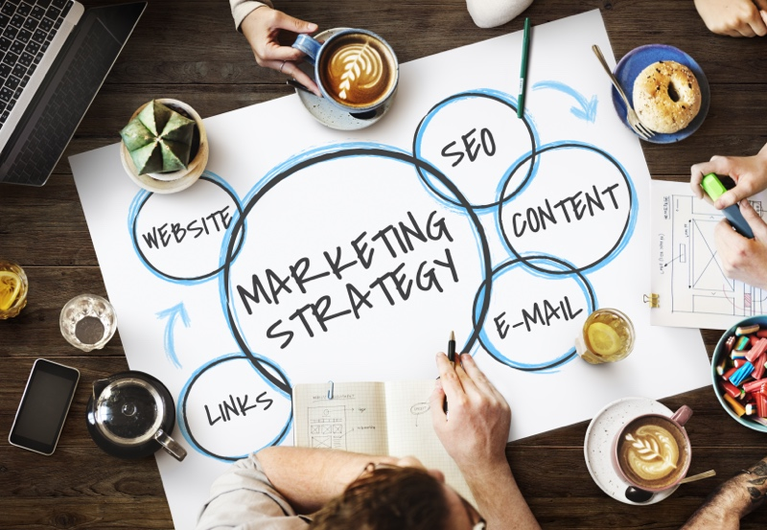
All of these factors can change the way you and the internal marketing team view, prioritize, and manage the agency relationship. Let’s first focus on defining the product’s lifecycle within a Biotech’s/Pharmaceuticals.

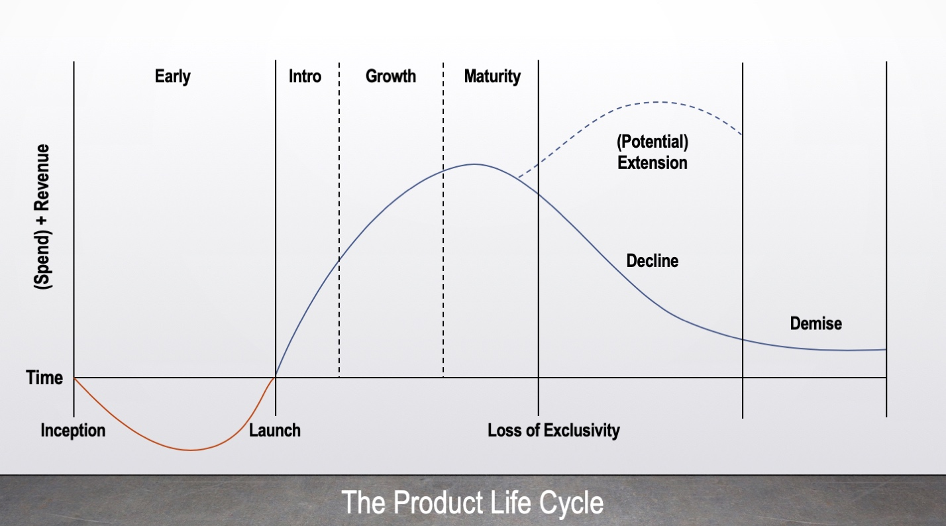

THe Product lifecycle - PLC

The product lifecycle can change based on industry, product characteristics, strategy, and a variety of other factors. Given industry importance of patent extension (re-branding) I’ve added it the original PLC for a 6-stage lifecycle.

Phase One (Development) - No Sales and High Expenses
Product is in the research (R&D) phase and only a prototype is available.

Phase Two (Introduction) – Sales Start Low and Highest Expenses of the Lifecycle
Product is put on the market and a huge increase in expenses should help stimulate market demand and awareness.

Phase Three (Growth) – High Sales and Moderate Expenses
Occurs if the product survives the introduction phase and results in high profit. If there are no sales, it will go straight to the decline phase.

Phase Four (Maturity) – Sales Moderate/Slowing and Low Expenses
The market becomes saturated and sales tend to level off. This can be an extended phase if the marketers have the right strategy in place.

Phase Five (Extension) – Moderate Sales and Moderate/Low Expenses
Either patent extensions to continue revenue generation without the introduction of competition, or re-branding. You want to stimulate sales to prevent decline.

Phase Six (Decline) – Declining Sales and Very Low Expenses
When demand ceases or ROI is close to zero, the product will be pulled from the market.
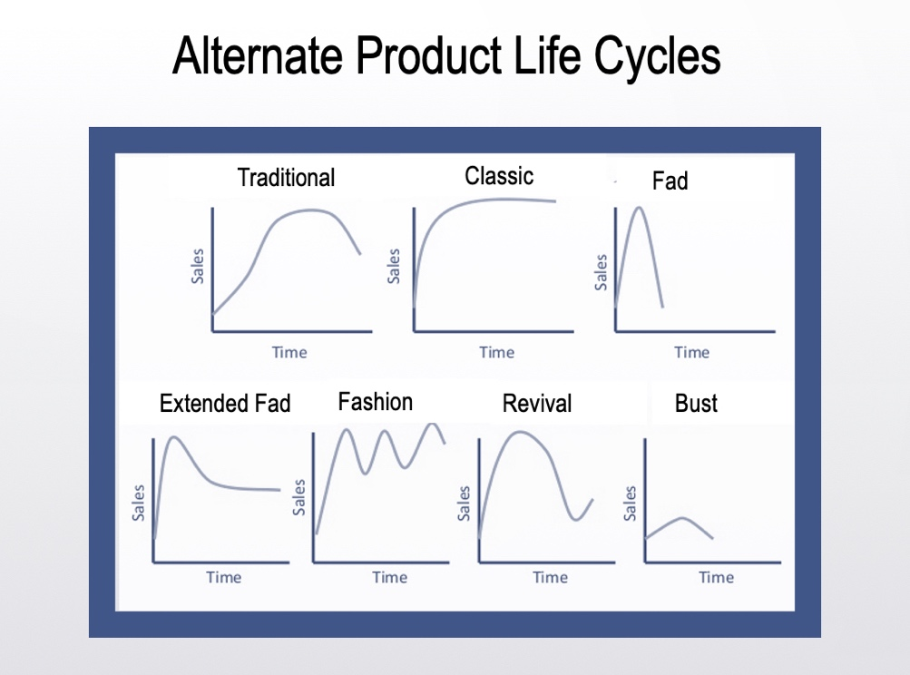
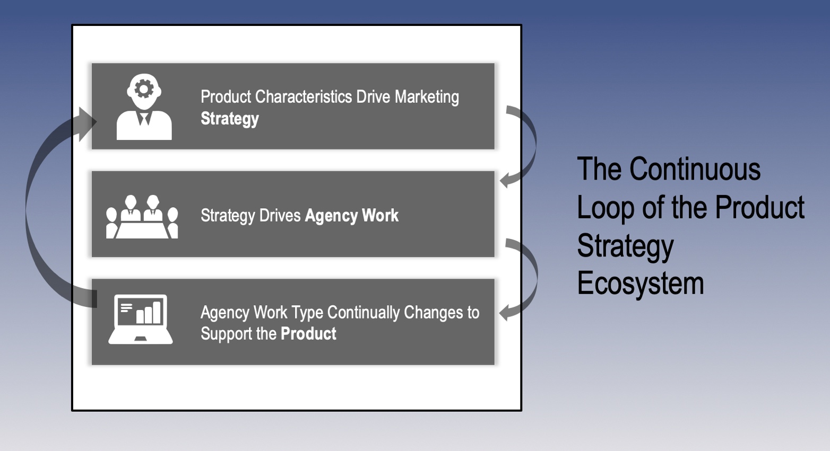

Why THe Product lifecycle Matters

- Changes in the lifecycle are driven by product characteristic changes.
- Characteristic changes marketing’s strategy / marketing mix.
- Mix dictates type of agency work/support level needed.
- Agency staff and work shifts to support the product / mix.

This is a continual loop that can happen over weeks, months or years. It all depends on the specific industry, product, and demand. It is an important tool for the marketing function, since it offers insight into the best strategies at each stage.
That’s what makes the constant reassessment so critical. The movement from one stage to the next not only changes strategy, but also work type (strategic v. tactical) and support (seniority of staff) needed from the agency. All of which has a huge impact on pricing.

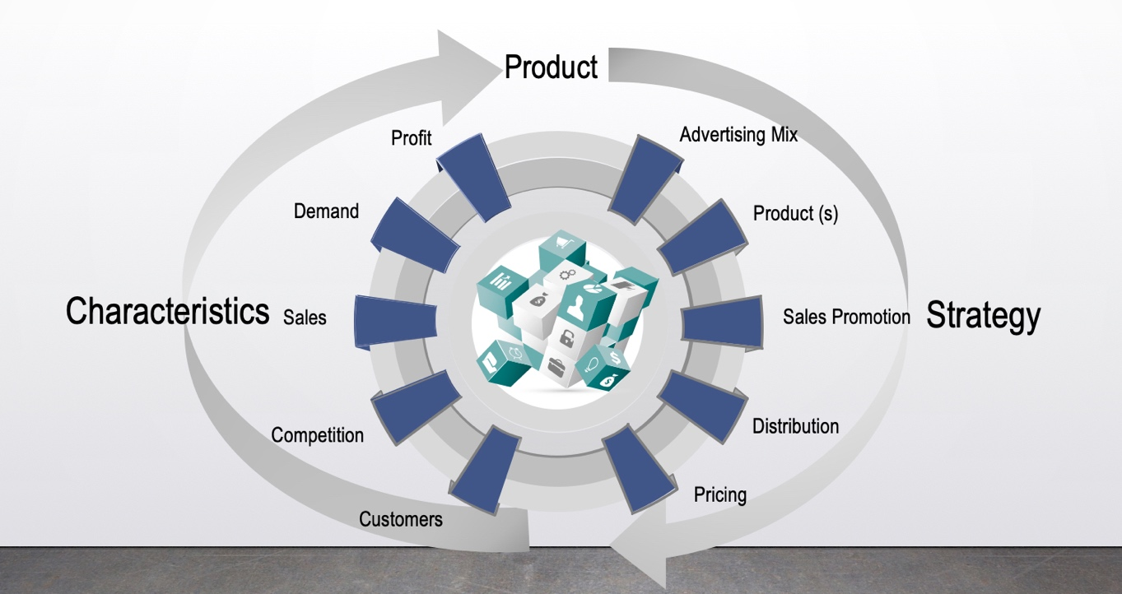
1.Lifecycle changes driven by Product Characteristics

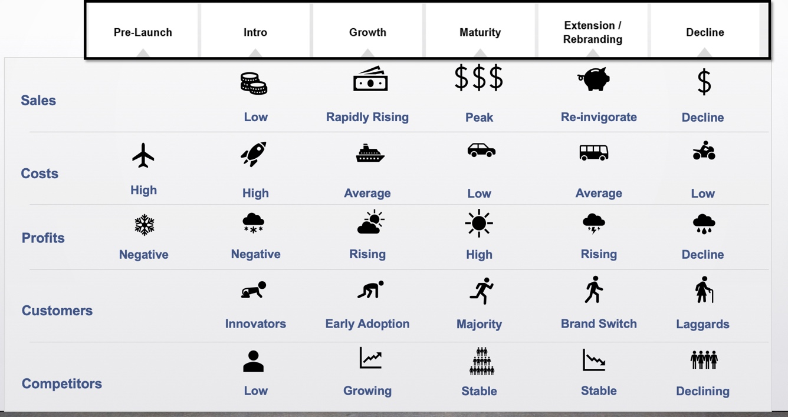
This isn’t a discussion of product characteristics such as to describe the product like: size, color, quality, weight or exact shape. These characteristics of the product in the marketplace such as amount of sales, profit, demand, competition, etc. When these characteristics change, so does the product’s marketing strategy/mix.
Table based on: Marketing Insider EU – managing each plc stage (Link)
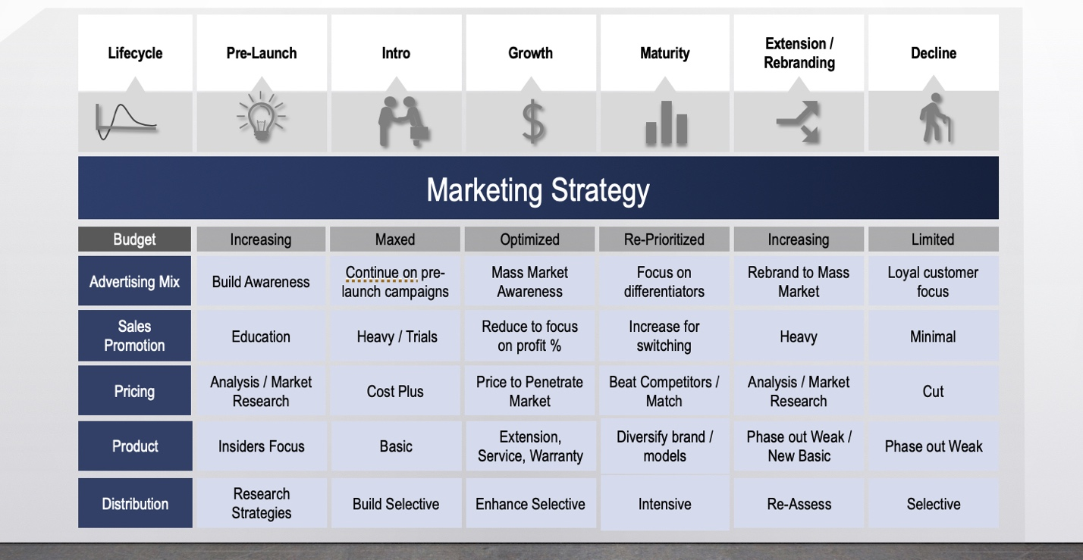
Table based on: Marketing Insider EU – Product life cycle strategies (plc) and characteristics – managing each plc stage (Link)

2. Marketing Mix / Strategy Changes

Budget – (Added in) Amount of OPEX matters for marketing mix potential. Typically decreases over the lifecycle, with rebranding as a potential exception.
Advertising Mix – Tactics (digital, web, print, projects) to build the brand image, and to increase market share. Optimal mix ensures high profits.
Sales Promotion – Amount of sales force support to build awareness and keep/gain market share. Also tends to decrease over the life of the product.
Pricing – Starts at level dictated by market research and will typically decrease over the lifecycle. Finding optimal price points, ensures you maximize profit.
Product – Expanding product lines, types, and refinement to meet market demand. Typically, with an expansion in phases of introduction and growth. Then a decrease when moving into maturity/decline.
Distribution - The ability to bring the product quickly to market and scale up/down. Helps assure maximum profits i.e. avoiding stock-outs, excess inventory, etc.

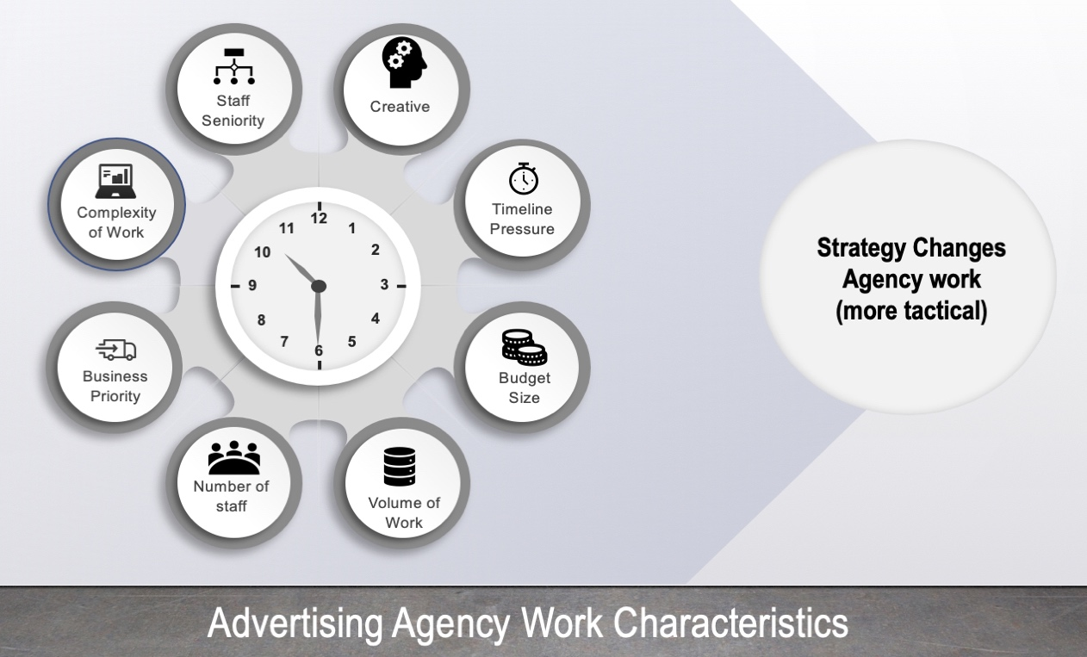
3. Agency Work (Support)

Development and Introduction (1st and 2nd) Phases
The most strategic work is being done in these phases, therefore requires: the most senior level staff, the best creative talent, ability to scale quickly, and to work under immense pressure.

Growth and Extension (3rd and 5th) Phases
There is a mix of strategic and ta. work (potentially with re-branding). The resources should reflect this with junior level staff being introduced and leveraged appropriately across projects

Maturity and Decline (4th and 6th) Phases
Due to the change in work (very tactical) the support should contain mostly junior level staff; resources should be optimized to support the shift to tactical work.

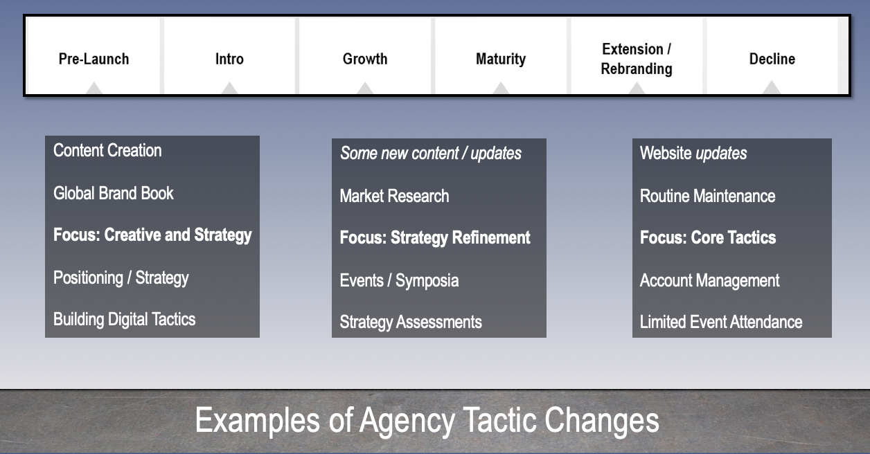

4. Tactic / Project Level Changes

Development and Introduction – Creative and Strategy
- Extensive market research used to test strategy
- New items (assets) are constantly being created
- Long term positioning and strategy will be set globally (then rolled regionally)
- Maximum creative support is needed

Growth, Maturity, Extension - Strategy Refinement
- Market research on competitors and demand
- Limited amount of new campaigns
- Mostly re-work or updates of existing assets
- Extension may include more new creative content vs. rework

Decline – Core Tactics
- Keep the lights on tactics including maintenance and account management
- Must be analyzed to ensure ROI stays positive to keep the product on market

Brand’s risk tolerance vs. agency reliance
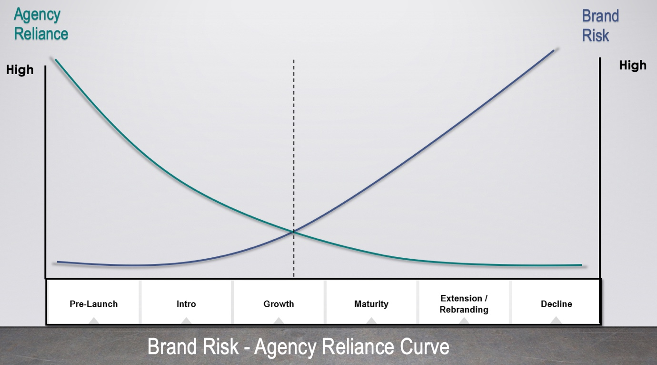

Development and Introduction Phases
- Strategy is an integral part of a successful launch (including the increase in sales) therefore, the brand is heavily reliant on the agency.
- Heavy reliance on taking key insights and translating them into strategy causes a strong risk aversion with the brand.
Growth, Extension and Maturity Phases
- As the product matures and market share is achieved, the brand reduces their reliance on the agency.
- This reduction in reliance, allows marketers to take more risk and involve procurement / sourcing (typically at the crossing point).
- This allows sourcing to push back on pricing, staff seniority and detailed review s and audits of SOWs.
Decline
- Give the product’s decline, marketers are more likely to support category management strategies. Including change management to processes.

Agency management best practices
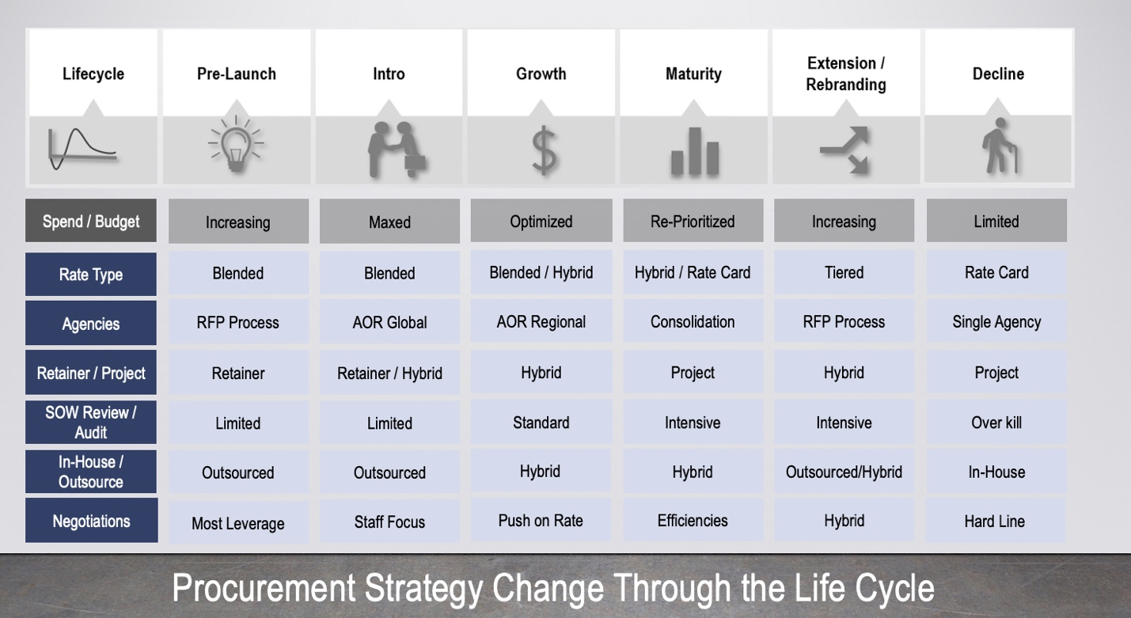
Best for small to mid-size companies. Large companies may want to deploy other tactics such as revenue/profit sharing, set pricing per asset, or even more strategic category strategies.

Rate Type
- Early phases where senior staff support and strategy, a blended rate is preferable to ensure correct support, without senior level rate card pricing.
- As you enter growth and maturity phases, either a lower blended rate should apply or a switch to a rate card (depending upon how much strategy, new assets are being produced).
- When moving into the last phases, you should move to either a tiered rate card (by brand, type of work digital, etc.) or just a simple rate card as junior level staff will be well below a blended rate (majority of hours are here).
- Rate is dependent upon level of staff and hours and project type, with that in mind you can adjust your strategy as needed.

Agencies
- We all know, marketers are very picky about the agencies they use. Nobody wants the “B” team or to share with another internal brand.
- Prior to launch, all agencies should go through the RFP process. Bringing in an agency because it was used at a different company is a recipe for disaster. (They may not have the same experience with disease state/product).
- When you are a small to medium company, you need leverage. Therefore, combining the RFP to include Global and Regional Groups provides a significant amount of savings. (Due to changes, rework, transfers that would otherwise happen).
- When a product is in the maturity to decline phase, you should either return to an RFP process or try to consolidate for leverage.

Retainer/Project
- If you are a small company with only a couple million in spend, you should look to try and leverage a retainer project (with lots of audits!). This is so the agency can secure the staff to ensure its success.
- Movement into project / asset-based pricing later in the lifecycle when costs can be standardized due to their similarities and lack of complexities.
- Hybrid approaches are useful when you need a specific skill set your AOR doesn’t have. It allows you the freedom to approach other agencies.

SOW Review/Audit
- Although bi-yearly to quarterly audits are a standard practice, you may receive push-back on doing so early in the lifecycle.
- Therefore, utilizing SRM practices can suffice in the early stages.
- Auditing / reconciliations can be increasingly useful for savings as you move along the product lifecycle.

In-House/Outsource
- In-housing is the new black when it comes to advertising agency trends.
- That said, you should do a careful make vs. buy assessment to understand if it works with your products no matter the placement in lifecycle.
- Don’t forget agencies make a profit, and a benefit to brining staff in-house is that you don’t have to pay that premium.
- You will never go wrong in bringing the tactical work (updates, minor edits and changes, etc.) in-house (little impact to the business).

Negotiations
- This is one of the most disputed categories for a multitude of reasons. Therefore, make sure you have your porter’s five forces, supplier perspective analysis, and other analysis in place prior to making a decision.
- That said, as a buyer you typically have the most leverage early on in a relationship. You should use this to your advantage during the early stages of agency selection.
- You should want to create a long-term partner. You will be able to find the most cost-efficiencies in doing so.
- Without the partnership, you should expect to churn and burn agencies at an accelerated pace due to the small profit margin.

Conclusion
- This is based on experience and best practices. You should make sure that you complete all applicable Sourcing Analysis PRIOR to making any drastic decisions or changes.
- If you work within a larger organization with spend, you should reassess best practices where you always have the upper hand.
- Although the presentation is Pharma. /Biotech. Specific, it will hold true in other industries if you have a smaller portion of the industry spend.

Key Takeaways on the Agency / Product Lifecyle management

1. If you are unsure of lifecycle phase, default to the SOW that details the specific project, staff and hours.
2. Make sure you update all pertinent analysis prior to making a final decision including: Supplier Perspective, Porter’s Five Forces, Kraljic Matrix, Current Position, Relationship Mapping, etc.
3. When all else fails and you are confused, fell free to reach out to me! I’m always available to help with assessments, planning, strategy, or whatever you need help with when it comes to sourcing!

Ms Category Management
Email:danagerenda@gmail.com / mscategorymanagement@gmail.com
LinkedIn: https://www.linkedin.com/in/dana-small-b3058127/
Page: https://www.linkedin.com/company/ms-category-management/
Twitter: @MsCategory or https://twitter.com/MsCategory

